***Feasibility study of AUTO CARE JUNCTION***

2021

**Table of contens**

**1 Introduction**

Overview of the project

Needs of the projects

Objectives of the project

Scope of the project

Deliverables

**2 Feasibility study**

Financial feasibility

Technical feasibility

Resource and time feasiliblity

Risk feasibility

Social/legal feasibility

**3 Considerations**

**4 References**

**<1> INTRODUCTIN**

**Overview of the project**

Auto care junction is an online system which provide

servies of vechicle booking and Manage Services

And Adding Offers and Manage Mechanics and Assign

Contract and Manage Contract and Calendar wise data

And Manage Accessories and Manage Stock and Due

Services Billing

**The needs of the project**

auto care junction is provide the automatic booking of car servies and also management of all the data and mechanic and payment of service and salary management in short ti is make easy to manage for holder and also for user or customer to get service in easy way.

**scop of the project**

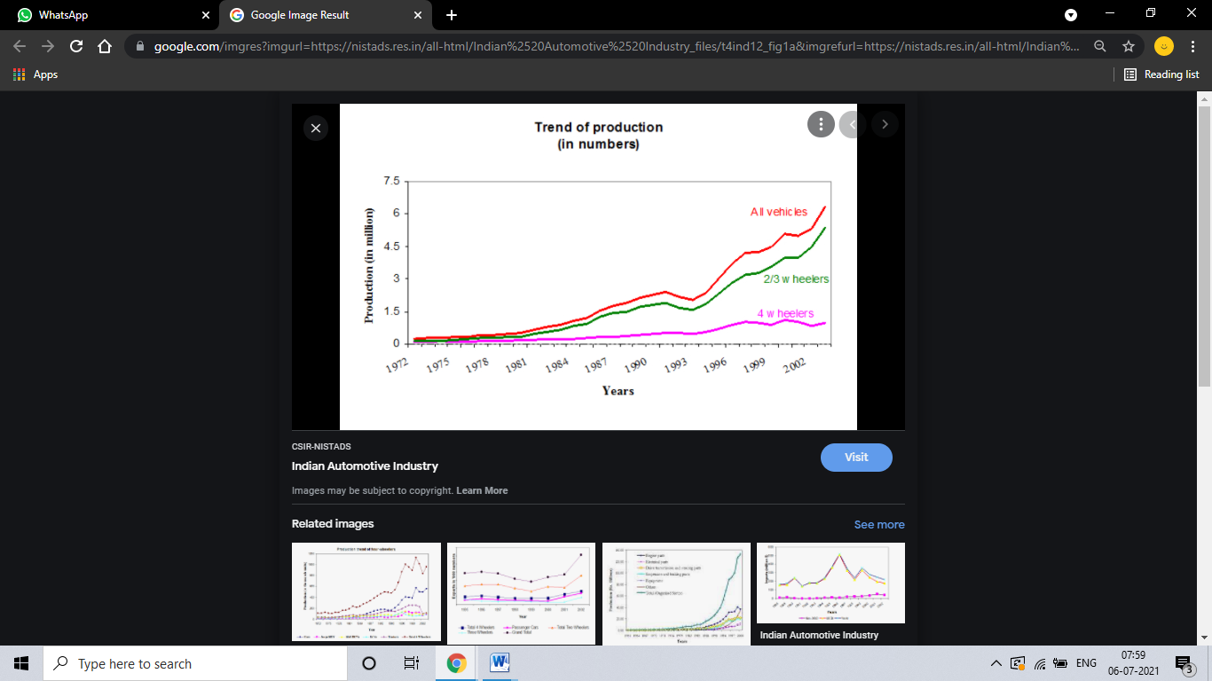

This is the graph of manufacturing and production of vechicals , day by day its go more and more up and if its use by peoples then ist may have a mentenance also. And our project / software can prove best for that work and helps to peoples to manage their vechicle .so there is the best scop of project.

**Deliverables**

A web based software sustem. This contain control database and functionalities for various user and also holder. Since many membr of holder involved and different GUIs will be provided to different users.

**<2> FEASIBILITY STUDY**

**Financial feasibility**

Financial Feasibility Being a web application ACJ will have an associated hosting cost. Since the system doesn’t consist of any multimedia data transfer, bandwidth required for the operation of this application is very low. The system will follow the freeware software standards. No cost will be charged from the potential customers. Bug fixes and maintaining tasks will have an associated cost. Beside the associated cost, there will be many benefits for the customers. since all the work generation is fully automated. From these it’s clear that the project ACJ is financially feasible.

**Technical feasibility**

 Technical Feasibility Project ACJ is a complete web based application. The main technologies and tools that are associated with ACJ are

• HTML

• CSS

• PHP

• MySQL

• SQL

Each of the technologies are freely available and the technical skills required are manageable. Time limitations of the product development and the ease of implementing using these technologies are synchronized. Initially the web site will be hosted in a free web hosting space, but for later implementations it will be hosted in a paid web hosting space with a sufficient bandwidth. Bandwidth required in this application is very low, since it doesn’t incorporate any multimedia aspect. From these it’s clear that the projectACJ is technically feasible.

**Resource and Time Feasibility**

Resource feasibility Resources that are required for the ACJ project includes,

• Programming device (Laptop)

• Hosting space (freely available)

• Programming tools (freely available)

• Programming individuals

So it’s clear that the project ACJ has the required resource feasibility.

**Risk feasibility**

 Risk feasibility can be discussed under several contexts.

Risk associated with size

Estimated size of the product in line of codes:

Being a web application with many number of stakeholders, ACJ will contain significant amount of code lines. As the system doesn’t contain any multimedia aspect, the file sizes and the complete project size will not exceed 200MB.

Estimated size of product in number of programs:

Though the application supports many holders, it will be constructed as a single web application with a single login page rather than having many number of sites for different users. Depending on the access rights, the contents will be showed or hidden.

Size of database created or used by the product:

Database size will not exceed the values supported by MySQL (65526 entries per table). Number of relations and entities are minimized by using best practices of normalization theories.

 Business impact risks

Effect of this product on company revenue:

ACJ can be implemented either as an individual system, or can be integrated to an existing system .Since it automates some key features associated car management or repireprocess, the users can increase the revenue.

Reasonableness of delivery deadlines:

Being a 14 weeks project, the project ACJ will have several deadlines and deliverables that are scheduled successively. Depending on the coding and designing cost and effort, the deadlines are quite reasonable.

Number of customers who will use this product and the consistency of their needs relative to the product:

As mentioned above, we can categorize holders into 4 main categories. This system can support many number of users simultaneously due to the low bandwidth requirements.

Sophistication of end users:

ACJ is designed while maintaining the complexity at a very low level. Usability is highly improved by providing help documents and making GUIs easy to use.

Amount and quality of product documentation that must be produced and delivered to the customer:

Customer will be provided with a complete online user manual.

As the software is implemented as a freeware and open source system, the code will be available for free Costs associated with delivery:

At the initial stage the associated cost will be for the hosting cost.

Customer related risks:

ACJ is a general type of product (not designed just for a single holder). Before implementing the system in management of car servise, there will be some basic modifications required.

Development environment risks

Is a software project management tool available?

Microsoft Project will be used as the main project management tool.

Are tools for analysis are available?

ACJ will require several designing software like …..

compilers or code generators available and appropriate for the product to be built?

…… will be used as the main scripting language.

All the libraries and interpreters will be freely available.

Are testing tools available and appropriate for the product to be built?

……is the main testing tool that will be used…… is freely available tool that supports automated testing.

Technology risks

Is the technology to be built new?

All the technologies are very well established and old enough (but not obsolete). Do the system requirements demand the creation of new algorithms.

Social/Legal Feasibility

ACJ uses freely available development tools, and provide the system as an open source system. Only the maintenance cost will be charged from potential customers.

…. Software libraries that are used in this system are free open source libraries.

Since this new system eliminates the effort to make statistical distributions, it will have a great impact in a university system.

**<3> CONSIDERATIONS**

Performance

ACJ requires a very low bandwidth, hence the performance will not degrade with increasing number of potential users. At the development stage, a free hosting service will be used. But when installing the system to a real business environment, it will be hosted in a much more reliable server to increase the performance. MySQL will provide the adequate speed for database transactions. Since no big data analysis is done, MYSQL is the ideal database for this project.

Response time: less than 2 seconds

Processing time: Less than 2 seconds (no batch processing involved) Query and reporting times: yet to be tested

Throughput: yet to be tested Storage: yet to be tested

Security

Security measures are provided in many aspects in this system.

User authentication

Users will have to authenticate using the username and passwords. Depending on the access level each user will gain functionality of the system. Passwords can be changed by the user.

Login details

Each user’s login time and logout time will be recorded in the system, to make the tractability process easy in case of a faulty action.

Usability and ease of use:

Users will be provided with a complete user manual as a pdf. The interfaces are designed to make it easy for any potential user to get familiar with the system within one hour. No additional training is required to use the system.

Capacity and scalability:

ACJ system can accommodate many simultaneous users. The system is designed to make it easy to integrate to an existing system like the Moodle system.

Availability:

System will be available throughout the 24 hours. Mean time to failure and mean time to repair will be decided to increase the availability. With a paid hosting space, the availability can be guaranteed to a great precision.

Maintainability

ACJ is designed using the best practices ….. Since every single segment in the system is very well structured, the system is highly maintainable. …… view model will be used as the main architectural pattern in this system. Hence the separation of each task is improved, hence maintainability improved

**<4>REFERENCES**

……..